WMU and EMSA cooperate on capacity building and research

**The World Maritime University (WMU) and the European Maritime Safety Agency (EMSA) have signed a Cooperation Agreement on matters of capacity building and research with particular emphasis on the design, development and delivery of joint training activities and modules falling under common areas of interest and research. In addition, it provides for Field Study Training exchanges for WMU students and EMSA beneficiaries as well as the exchange of lecturers.**

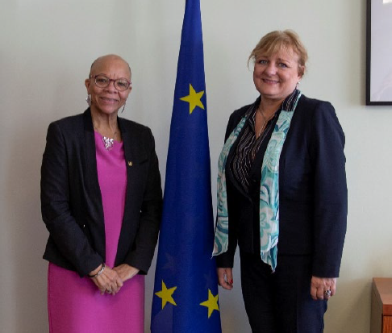Dr Cleopatra Doumbia-Henry, President of WMU, welcomed the agreement saying, “WMU is pleased to further strengthen its cooperation with EMSA to achieve our common goals in the fields of maritime safety, security, environmental protection and pollution response. With over 80 per cent of the world’s goods carried by shipping, the maritime community is key to global financial sustainability. Our efforts relate to [United Nations 2030 Sustainable Development Goal 17](https://www.un.org/sustainabledevelopment/development-agenda/) focused on global partnerships, and our mutual cooperation will contribute to the achievement of the [UN 2030 Sustainable Development Agenda](https://www.un.org/ga/search/view_doc.asp?symbol=A/RES/70/1&Lang=E).”

Mrs Maja Markovčić Kostelac, Executive Director of EMSA, welcomed the cooperation agreement and stated that “EMSA is moving towards a new approach on capacity building which entails among others the professional development programme for officials from Member States, Enlargement Countries and beneficiary states of the European Neighbourhood Policy. WMU with its long-standing experience and expertise will offer valuable support, will foster our potentials and will enrich the knowledge and competencies of our subset experts that will be the cornerstone of our soon to be established EMSA Academy.”

EMSA is one of the EU's decentralised agencies. Based in Lisbon, the Agency provides technical assistance and support to the European Commission and Member States in the development and implementation of EU legislation on maritime safety, pollution by ships and maritime security. It has also been given operational tasks in the field of oil pollution response, vessel monitoring and in long range identification and tracking of vessels. EMSA is also responsible to build capacity at national level, to foster cooperation and to disseminate best practices, thereby achieving uniform implementation of the maritime legislation and ensuring a level playing field.

In February of 2019, EMSA launched the [“European Neighbours Policy” Maritime Fellowships at WMU](https://www.wmu.se/news/emsa-launches-european-neighbours-policy-maritime-fellowships-wmu). The fellowships are provided under the framework of the EU-funded regional projects “SAFEMED IV EuroMed Maritime Safety project” and “Maritime safety, security and marine environmental protection in the Black and Caspian Sea Regions” (BCSEA). The fellowships enabled staff members from the maritime administrations of the beneficiary countries of the SAFEMED IV project and the BCSEA project to enroll in the 14 months Standard Master Programme in Maritime Affairs (Fellowship) offered by WMU with the financial and managerial support by EMSA. The Agency funded five fellowships (two for the SAFEMED IV project and three for the BCSEA project) for students in the Class of 2020.